**HOMEPAGE IS ENDLESS SCROLL - SHOWING WORK - USE ‘SEEN ON’ PAGE AS HOMEPAGE**

[**https://www.shionaturini.com/home-page**](https://www.shionaturini.com/home-page)

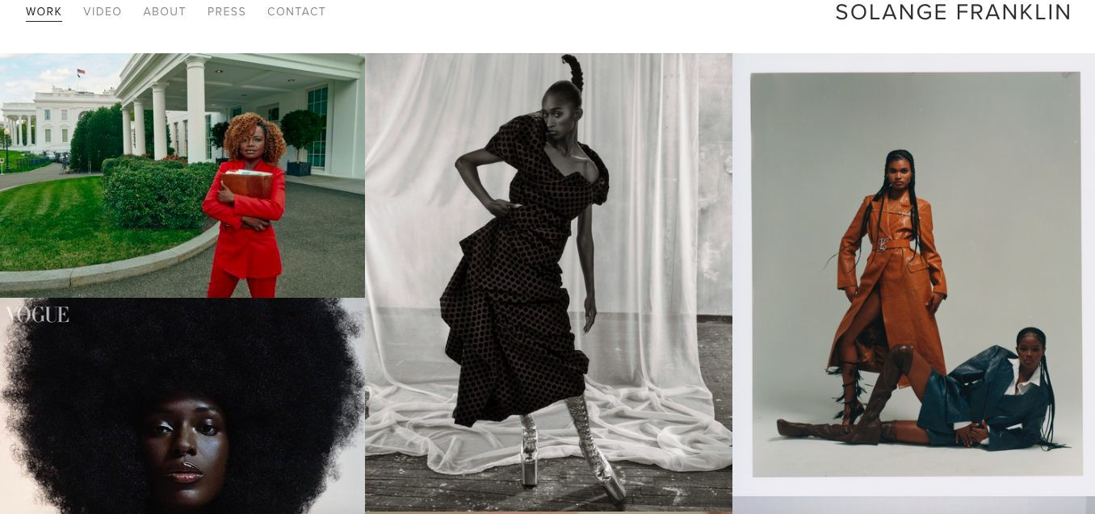

# COLLABORATION TAB

<https://www.ganni.com/us/collabs.html>

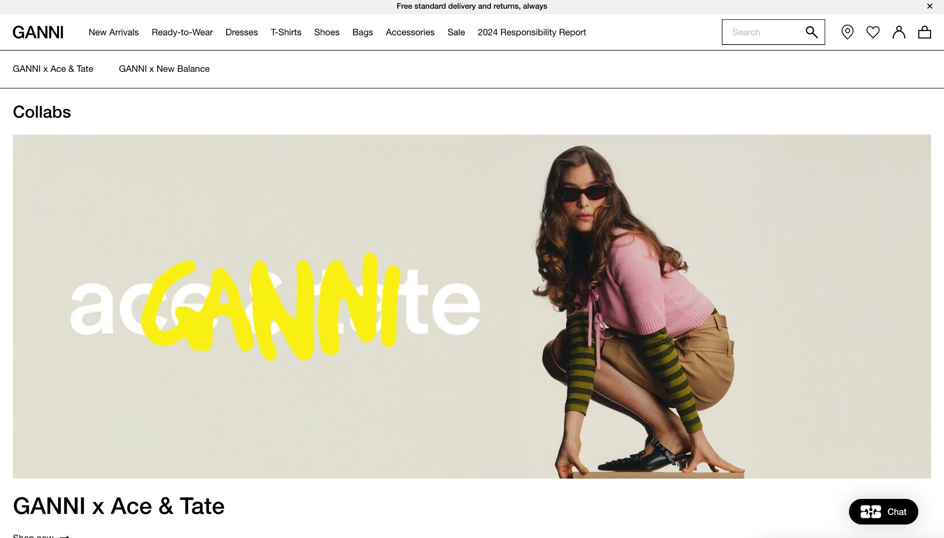Banner size image boxes + minimalistic text

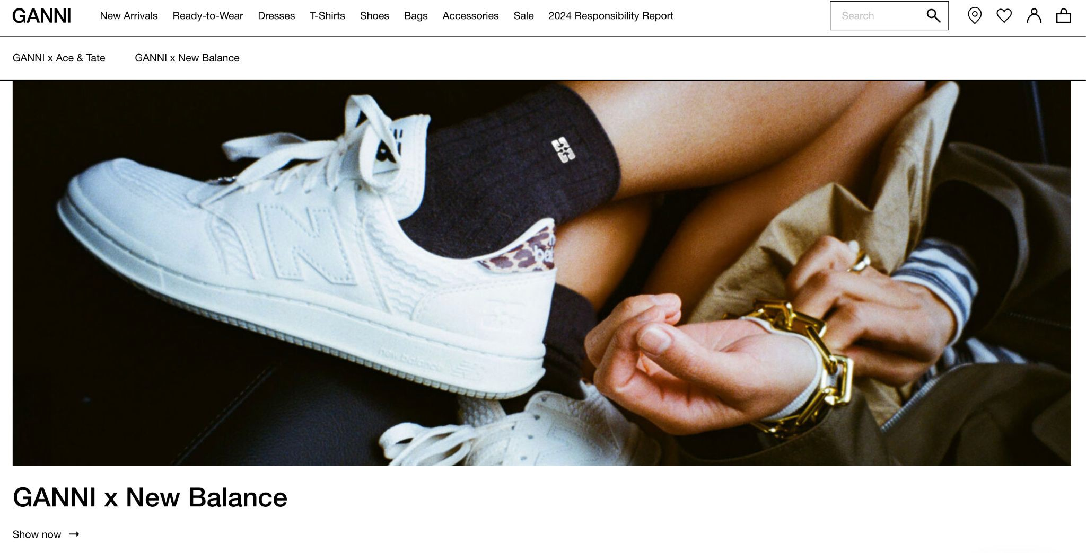

# INFORMATION TAB

<https://www.ganni.com/us/collabs.html>

Banner size image boxes + minimalistic text



# SEEN ON TAB

[**https://www.zerinaakers.com/**](https://www.zerinaakers.com/) **-**

## Full screen video layout

**Vision & Layout Inspiration for My Website**

This deck includes references from websites I love, the overall layout I’m drawn to, and the must-have features I’d like to see brought to life for my own site. My goal is to create an experience that feels elevated, editorial, and reflective of my work in the fashion industry.

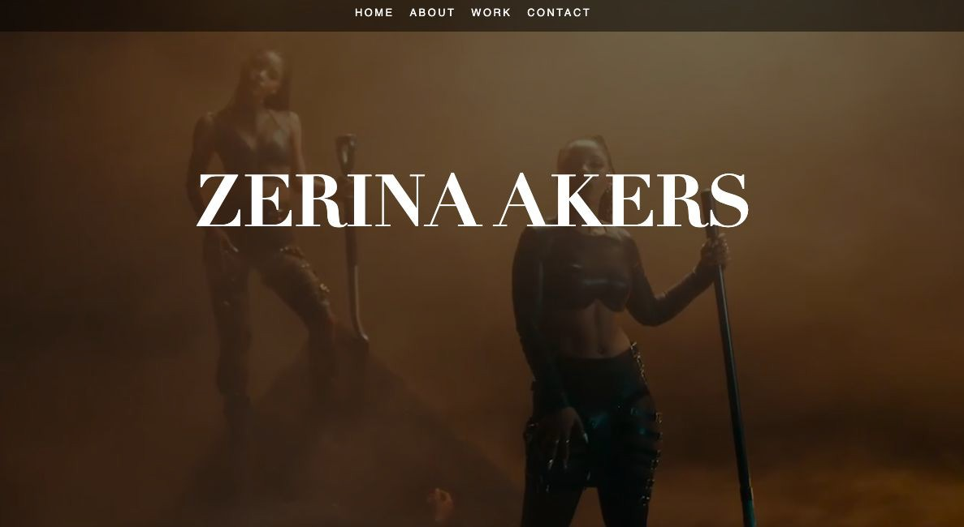

**SHOP - i like layout of product** [**https://www.venedacarter.com/**](https://www.venedacarter.com/)

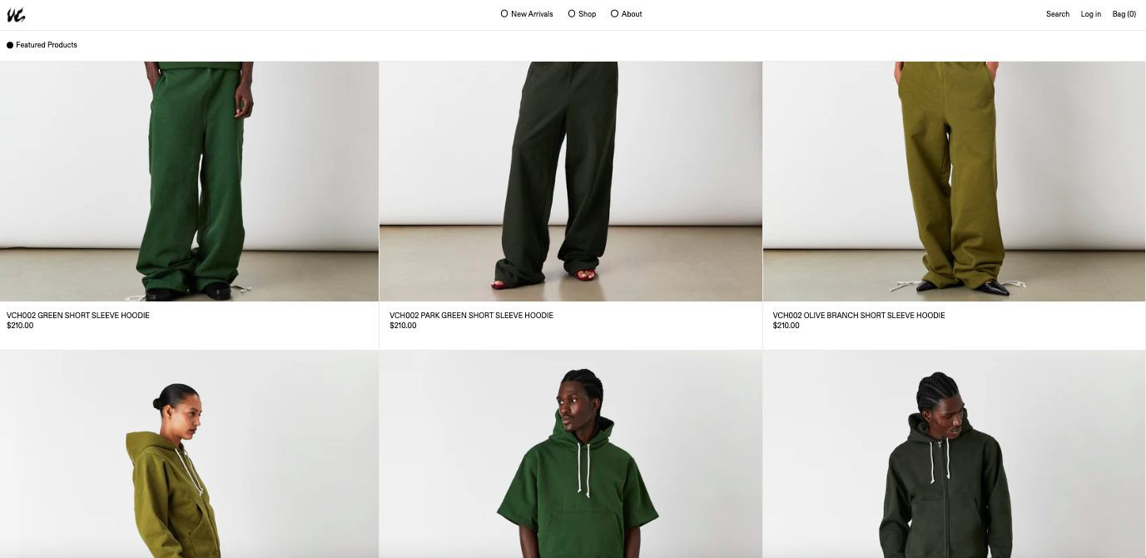

**CONTACT PAGE - i like personal photo + information on side of**

